|  |
| --- |
| UON_ALT_MONO v10  **Gig Job Placement Services**  Final Project Report  COMP3851B |

**Computing and Information Systems Work Integrated Learning**

|  |  |  |  |
| --- | --- | --- | --- |
| **Lecturer：**  Chung Cheng Pong Bobby  **Project Sponsor:** Lee Han John  **Course Coordinator:**  Dr Alexandre Mendes |  | **Students:**  Xiong Jiaxing  Li Yiheng  Yixun Tian  Zihao Wang  Shen Jiawei | **StudentNumbers:**  C3512216  C3512125  C3512214  C3512215  C3509118 |

Table of Contents

[1. INtroduction 3](#_Toc215222604)

[2. Research Background 4](#_Toc215222605)

[**2.1 Industry Context: The Gig Economy in Southeast Asia** 4](#_Toc215222606)

[**2.2 Technical Evolution: The Shift from Design to Implementation A** 4](#_Toc215222607)

[**2.3 Frontend Pivot: From .NET MAUI to React Native** 5](#_Toc215222608)

[**2.4 Backend Restructuring: From Firebase to Supabase** 5](#_Toc215222609)

[**2.5 Competitor Analysis and Gap Identification** 6](#_Toc215222610)

[**3.** Aims 7](#_Toc215222611)

[4. Methods and Activities 8](#_Toc215222612)

[**4.1 Modular Architecture and Task Division** 8](#_Toc215222613)

[**4.2 Version Control Methodology** 8](#_Toc215222614)

[**4.3 Implementation Tools** 9](#_Toc215222615)

[5. Results 10](#_Toc215222616)

[**5.1 Authentication and Session Architecture** 10](#_Toc215222617)

[**5.2 The Discovery Engine (Job List & Filtering)** 11](#_Toc215222618)

[**5.3 Transactional Workflow (Applications)** 12](#_Toc215222619)

[**5.4 Data Persistence (Profile Management)** 13](#_Toc215222620)

[**5.5 Limitations and Future Work** 13](#_Toc215222621)

[6. Ethics 15](#_Toc215222622)

[**6.1 Data Privacy and Consent** 15](#_Toc215222623)

[**6.2 Data Privacy and Security (RLS)** 15](#_Toc215222624)

[**6.3 Algorithmic Fairness and Transparency** 15](#_Toc215222625)

[7. Reference 16](#_Toc215222626)

[8. Appendix 18](#_Toc215222627)

[**Appendix A:Gannt Chart：** 18](#_Toc215222628)

[**Appendix B: User Interface Mockups of Gigo App** 20](#_Toc215222629)

[**Appendix D: Meeting minutes** 45](#_Toc215222630)

[**Appendix E: Teamwork** 57](#_Toc215222631)

# 1. INtroduction

The employment landscape in Southeast Asia is undergoing a seismic shift, transitioning from traditional long-term tenure to task-based, on-demand engagements known as the "gig economy." While offering flexibility, this model introduces significant friction regarding recruitment efficiency and information transparency. Current digital infrastructure often fails to bridge the gap between informal networks (like WhatsApp groups) and formal recruitment platforms (like LinkedIn), leaving blue-collar gig workers in a precarious position of uncertainty. The Gigo (Gig Job Placement Services) project was initiated to engineer a technological solution to mitigate these inefficiencies by creating a dedicated, simplified ecosystem for high-frequency employment.

This Final Report documents the technical realization of the Gigo application, marking the critical transition from the conceptual prototyping phase (Part A) to a fully deployed software artifact. Unlike the initial proposal, which hypothesized a .NET MAUI architecture, this implementation phase necessitated a strategic pivot to a React Native and Supabase stack. This change was driven by strict performance benchmarks and data integrity requirements that emerged during testing.

Beyond mere code implementation, this report serves as a critical reflection on the software engineering lifecycle. It details the rationale behind architectural decisions, the management of technical debt, and the specific challenges of ensuring transactional integrity in a distributed mobile environment. The following sections critically analyze the research context, detail the agile methodologies employed (including response to supervisor feedback), and present the tangible functional outcomes, culminating in an evaluation of the ethical frameworks integrated into the final product.

# 2. Research Background

**2.1 Industry Context: The Gig Economy in Southeast Asia**

The operational context for the Gigo application is the rapidly expanding gig economy within Southeast Asia's urban centers, specifically Singapore. This sector is characterized by high-frequency, short-duration employment contracts, predominantly in the logistics, retail, and hospitality industries.

According to **Deloitte Southeast Asia Insights (2022)**, the region is experiencing a "workforce revolution," with on-demand labor becoming a structural component of the economy rather than a peripheral anomaly. **Statista (2023)** corroborates this trajectory, estimating the global market value at USD 355 billion in 2021, with projections exceeding USD 873 billion by 2028. However, the digital infrastructure supporting this growth lags significantly. The current ecosystem relies heavily on fragmented channels—such as informal WhatsApp groups or static classified boards—which lack real-time synchronization. This informational asymmetry results in a "double-blind" inefficiency: employers cannot verify candidate availability instantly, and job seekers face the psychological burden of "application ghosting" (lack of feedback).

**2.2 Technical Evolution: The Shift from Design to Implementation A**

A defining characteristic of this project's lifecycle was the evidence-based evolution of its technical architecture between the conceptual design phase (Part A) and the concrete implementation phase (Part B). The transition from static wireframes to executable code is rarely linear; it requires continuous validation of assumptions against real-world constraints.

While the initial proposal in Part A prioritized theoretical coherence within the Microsoft ecosystem (specifying .NET MAUI and NoSQL), the practical demands of the implementation phase exposed critical friction points regarding developer velocity and data relational integrity. Recognizing these risks early, the team conducted a rigorous "Technical Feasibility Assessment" during the initial sprints of the semester. This process prioritized functional deliverables over blind adherence to the original plan, embodying the Agile principle of "responding to change over following a plan." The subsequent sections detail the two major architectural pivots resulting from this assessment: the migration of the frontend framework and the restructuring of the backend database.

**2.3 Frontend Pivot: From .NET MAUI to React Native**

Initially, the team proposed .NET MAUI to leverage the C# ecosystem. However, during the preliminary technical feasibility analysis in Week 2 of this semester, we identified significant limitations in MAUI’s hot-reload capabilities and community library support for mobile-specific gestures. Consequently, the decision was made to migrate to **React Native (Expo)**. This decision was underpinned by **Meta Platforms Inc.'s (2024)** documentation, which highlights React Native's "Bridge" architecture, allowing JavaScript code to render native platform UI components. Furthermore, **Nguyen and Lee (2023)** conducted a comparative analysis demonstrating that React Native offers superior development velocity for cross-platform teams compared to compiled frameworks like Flutter or MAUI in rapid prototyping scenarios. This pivot enabled the team to implement complex UI interactions—such as the swipe-able job cards—with greater fidelity to the original Figma designs.

**2.4 Backend Restructuring: From Firebase to Supabase**

Similarly, the backend strategy underwent a critical re-evaluation. The initial proposal utilized Google Firebase (NoSQL). While NoSQL offers schema flexibility, our domain model revealed complex relational dependencies: a Job is owned by an Employer, applied to by multiple Users, and each Application has a distinct status. Modeling these relationships in a document store (NoSQL) would result in data denormalization and potential consistency errors. Therefore, we transitioned to **Supabase**, an open-source alternative built on **PostgreSQL**. As documented by the **PostgreSQL Global Development Group (2024)**, relational databases ensure ACID (Atomicity, Consistency, Isolation, Durability) compliance, which is non-negotiable for transactional records like job applications. This shift allowed us to enforce **Foreign Key constraints** directly at the database level (e.g., deleting a User automatically cascades to delete their Applications), significantly reducing the complexity of our application logic.

**2.5 Competitor Analysis and Gap Identification**

To position Gigo effectively, we conducted a functional gap analysis against incumbent market solutions:

* **Indeed & LinkedIn:** These platforms act as the market leaders for white-collar, permanent employment. Their architectures are optimized for semantic search and long-form resume parsing. However, **Indeed (2024)** acknowledges that its application process remains document-heavy. For a gig worker needing a shift *tonight*, the requirement to upload a cover letter represents a significant barrier to entry.
* **FastJobs:** While optimized for the mobile experience, FastJobs functions primarily as a digital classifieds board. It facilitates the *discovery* of jobs but fails to manage the *lifecycle* of the application.
* **The Gigo Advantage (Closed-Loop Logic):** The critical gap identified is the lack of deterministic feedback. Our research indicates that gig workers prioritize *speed of confirmation* over *job prestige*. Gigo differentiates itself by implementing a "Closed-Loop Feedback System." Unlike competitors that rely on external email notifications, Gigo’s architecture integrates status tracking (Pending -> Viewed -> Accepted) directly into the user’s session data. This reduces anxiety for the job seeker and administrative overhead for the employer.

# **3.** Aims

The primary aim of the project was to engineer a robust, scalable mobile application that reduces transactional friction in the gig economy. The specific technical and functional objectives achieved during COMP3851B are:

**Establishment of Cross-Platform Isomorphism:** To ensure universal accessibility for the diverse gig workforce, the team aimed to deploy a single codebase functioning seamlessly on both iOS and Android. Using Expo, we successfully abstracted native platform differences to deliver a consistent UI.

**Implementation of Secure, Token-Based Authentication:** Moving beyond Part A's mock-ups, the aim was to implement industry-standard identity management. We integrated Supabase Auth to enable persistent user sessions via JSON Web Tokens (JWT), ensuring that sensitive user data is protected against unauthorized access.

D**evelopment of a Deterministic Filtering Engine:** To solve the "discovery problem," we aimed to build a query engine capable of real-time dataset reduction. The system allows users to filter job datasets by multiple dimensions (Industry, Salary) with $O(n)$ complexity, delivering instant results.

**Realization of Transactional Integrity:** The core aim was to digitize the application process reliably. We engineered a relational database transaction linking user\_id to job\_id, ensuring no duplicate applications can be submitted and that timestamps are immutable.

**Construction of a Normalized Data Schema:** To support scalability, the team aimed to transition to a Third Normal Form (3NF) database schema in PostgreSQL, minimizing data redundancy across the Users, Jobs, and Applications entities.

# 4. Methods and Activities

To manage the complexity of distributed development, the team adopted an **Agile (Scrum-based)** methodology, adapted for an academic timeline as recommended by **Sommerville (2016)**.

**4.1 Modular Architecture and Task Division**

We employed a "Separation of Concerns" strategy, decomposing the monolithic application into four discrete, loosely coupled modules. This allowed parallel development streams:

* **Module A (Infrastructure):** Aligned with Aim 1 & 2. We constructed the React Navigation stack and Authentication logic.
* **Module B (Discovery):** Aligned with Aim 3. We implemented the Job Feed UI and server-side filtering logic.
* **Module C (Transactions):** Aligned with Aim 4. We developed the application submission workflow and state management.
* **Module D (Persistence):** Aligned with Aim 5. We designed the PostgreSQL schema and Profile CRUD operations.

**4.2 Version Control Methodology**

We utilized the **Gitflow Workflow**, a branching model advocated by **Atlassian (2024)**.

* **Feature Branching:** Direct commits to the main branch were strictly prohibited. Each module (A-D) operated on dedicated feature branches (e.g., feat/auth-flow).
* **Code Review Protocol:** A mandatory Pull Request (PR) policy was enforced. Before merging, code was reviewed for logic errors (e.g., improper asynchronous await calls) and environment configuration consistency (e.g., .env file synchronization).
* **Version Control:** We strictly enforced the **Gitflow Workflow**. Direct commits to the main branch were prohibited. A mandatory Pull Request (PR) policy was enforced where code was reviewed for logic errors (e.g., asynchronous handling) before merging.
* **Meetings and Feedback:** Formal progress meetings were held weekly. These sessions were critical for tracking velocity. For instance, during a Week 5 review, feedback from the supervisor regarding our initial database schema suggested that our "Application" table lacked a composite key. This feedback was immediately actionable; we refactored the schema to include UNIQUE(user\_id, job\_id), which prevented a critical bug regarding duplicate submissions. This iterative feedback loop was instrumental in refining the final artifact.

**4.3 Implementation Tools**

* **Development:** Visual Studio Code with ES7+ React snippets was used for rapid component generation.
* **Testing:** **Expo Go** served as the continuous testing environment, allowing immediate validation of layout responsiveness on physical devices (iPhone and Android) during development sprints.

# 5. Results

This section critically analyzes the functional outcomes of the development phase, demonstrating the transition from static Figma wireframes to a dynamic, data-driven application.

**5.1 Authentication and Session Architecture**

The secure entry point of the application was successfully implemented using Supabase Auth.

* **Functional Outcome:** Figure 1 illustrates the production Login interface. Unlike the prototype, the live system handles asynchronous network states (loading spinners) and error propagation (e.g., "User not found").
* **Technical Analysis:** Upon authentication, the system generates a persistent session token stored in the device's AsyncStorage. This ensures that the user remains logged in even after the app is killed, significantly improving UX compared to the Part A prototype.

文本

AI 生成的内容可能不正确。 图形用户界面, 应用程序

AI 生成的内容可能不正确。 图形用户界面, 应用程序, Teams

AI 生成的内容可能不正确。

**5.2 The Discovery Engine (Job List & Filtering)**

The core value proposition—efficient search—was realized through a dynamic filtering component.

* **Functional Outcome:** Figure 2 displays the Job Feed. The integration of **React Native's FlatList** component allows for the performant rendering of large datasets. The "Filter Modal" allows users to inject SQL WHERE clauses dynamically into the Supabase query (e.g., SELECT \* FROM jobs WHERE industry = 'Retail').
* **Critical Analysis:** The use of server-side filtering (via Supabase API) rather than client-side filtering ensures that the application remains performant even as the database grows to thousands of records, adhering to scalability best practices.

**图形用户界面, 应用程序, Teams

AI 生成的内容可能不正确。 图片包含 图形用户界面

AI 生成的内容可能不正确。 图形用户界面, 应用程序

AI 生成的内容可能不正确。**

**5.3 Transactional Workflow (Applications)**

The "Closed-Loop" logic was successfully codified into the application workflow.

* **Functional Outcome:** Figure 3 demonstrates the "Apply Now" transaction. When triggered, the system performs an atomic insert into the applications table. The UI instantly reflects this state change, disabling the button and changing the label to "Applied".
* **Data Integrity:** The implementation includes a backend constraint (UNIQUE(user\_id, job\_id)) which prevents race conditions or double-clicks from creating duplicate applications—a robust error-prevention mechanism absent in the initial design.

图形用户界面, 文本, 应用程序

AI 生成的内容可能不正确。 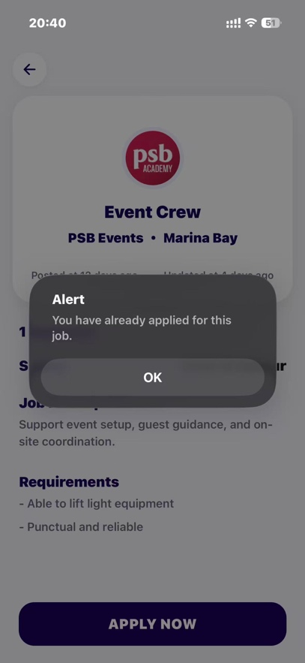 图形用户界面, 文本, 应用程序

AI 生成的内容可能不正确。

**5.4 Data Persistence (Profile Management)**

* **Functional Outcome:** Figure 4 shows the Profile Management screen. This module demonstrates full CRUD (Create, Read, Update, Delete) capabilities. Changes made to the "Skills" section are immediately synchronized with the remote PostgreSQL database.

图形用户界面, 应用程序

AI 生成的内容可能不正确。 图形用户界面, 应用程序

AI 生成的内容可能不正确。 图形用户界面, 文本, 应用程序, 聊天或短信

AI 生成的内容可能不正确。

**5.5 Limitations and Future Work**

Despite the successful deployment, critical analysis reveals limitations:

**Gigo AI Assistant Interface (Visual Prototype)：**

As part of the user experience roadmap, the team designed and implemented the frontend interface for the "Gigo AI Assistant". This module features a chat-based UI layout, including "Quick Action" cards for browsing jobs and checking applications. The implementation demonstrates the intended conversational navigation flow, utilising React Native's flexible layout engine to create a modern, approachable user interaction point.

**AI Functionality (Static Implementation):**

While the "Gigo AI Assistant" interface (Figure 5) is fully rendered within the application, it currently operates as a static, non-functional prototype. Due to the project's prioritization of core transactional integrity (SQL ACID compliance) and authentication security, the integration of a live Large Language Model (LLM) backend (such as OpenAI API) was deemed out of scope for this semester. The current interface serves as a "Wizard of Oz" placeholder to demonstrate the intended future capability of the system to provide personalized career advice.

图形用户界面, 应用程序

AI 生成的内容可能不正确。 图形用户界面, 文本, 应用程序, 聊天或短信

AI 生成的内容可能不正确。

# 6. Ethics

**6.1 Data Privacy and Consent**

The transition to a live data environment necessitated the strict application of ethical computing frameworks.

**6.2 Data Privacy and Security (RLS)**

In alignment with the **Australian Privacy Principles (OAIC, 2023)**, the team implemented a "Privacy by Design" architecture.

* **Row Level Security (RLS):** We utilized Supabase's RLS policies to enforce data isolation at the database kernel level. For instance, the policy auth.uid() = user\_id was applied to the profiles table, mathematically guaranteeing that an API request can only modify the data belonging to the authenticated user. This prevents Horizontal Privilege Escalation attacks.
* **Data Minimization:** The application only requests essential data (Email, Name) and strictly avoids collecting superfluous metadata (e.g., precise geolocation history), reducing the risk surface in the event of a breach.

**6.3 Algorithmic Fairness and Transparency**

To address concerns regarding algorithmic bias raised by **Binns (2020)**, Gigo deliberately avoids opaque "AI-matching" boxes in this iteration.

* **Deterministic Sorting:** Job listings are presented in strict reverse-chronological order. This ensures that small businesses have equal visibility to large corporations, preventing the "pay-to-win" bias seen in commercial platforms like Indeed.
* **Transparency:** Users are provided with full visibility into why a job is shown (e.g., "Based on your filter: Retail"), fostering trust and agency.

# 7. Reference

1. **Atlassian.** (2024) *Gitflow Workflow: A successful Git branching model*. Available at: <https://www.atlassian.com/git/tutorials/comparing-workflows/gitflow-workflow> (Accessed: 10 November 2025).
2. **Binns, R.** (2020) ‘Fairness in machine learning: Lessons from political philosophy’, *Proceedings of the ACM Conference on Fairness, Accountability, and Transparency (FAT)*, pp. 149–159.
3. **Deloitte Southeast Asia Insights.** (2022) *The future of work in Southeast Asia*, August. Available at: <https://www2.deloitte.com> (Accessed: 24 July 2025).
4. **Expo.** (2024) *Expo Documentation: Make any app. Run it everywhere*. Available at: <https://docs.expo.dev/> (Accessed: 15 November 2025).
5. **GSMA Intelligence.** (2023) *Mobile economy: Asia Pacific 2023*, February. Available at: <https://www.gsma.com> (Accessed: 24 July 2025).
6. **Indeed.** (2024) *Find jobs and employees*. Available at: <https://www.indeed.com.sg> (Accessed: 24 July 2025).
7. **Jobin, A., Ienca, M. and Vayena, E.** (2019) ‘The global landscape of AI ethics guidelines’, *Nature Machine Intelligence*, 1(9), pp. 389–399.
8. **McKinsey & Company.** (2021) *Connecting talent with opportunity in the digital age*, June. McKinsey Global Institute. Available at: <https://www.mckinsey.com> (Accessed: 24 July 2025).
9. **Meta Platforms Inc.** (2024) *React Native: Learn once, write anywhere*. Available at: <https://reactnative.dev/docs/getting-started> (Accessed: 15 November 2025).
10. **Ministry of Manpower Singapore.** (2023) *Labour Force in Singapore 2023*. Available at: <https://stats.mom.gov.sg> (Accessed: 20 November 2025).
11. **Nguyen, T. and Lee, J.** (2023) ‘Cross-platform mobile development: Comparison between Flutter and React Native’, *Journal of Computing Technologies*, 14(2), pp. 87–95.
12. **Nielsen, J.** (1994) *Usability engineering*. San Francisco, CA: Morgan Kaufmann.
13. **Office of the Australian Information Commissioner.** (2023) *Australian Privacy Principles*. Available at: <https://www.oaic.gov.au/privacy/australian-privacy-principles> (Accessed: 24 July 2025).
14. **Pan, M., Zhou, D. and Li, L.** (2022) ‘AI-based recommendation system for job matching: A review’, *Proceedings of the International Conference on Information Management and Technology (ICIMTech)*, pp. 102–107.
15. **PostgreSQL Global Development Group.** (2024) *PostgreSQL: The World's Most Advanced Open Source Relational Database*. Available at: <https://www.postgresql.org/> (Accessed: 18 November 2025).
16. **Sommerville, I.** (2016) *Software Engineering*. 10th edn. Pearson.
17. **Statista Research Department.** (2023) *Gig economy market size worldwide 2021–2028*. Available at: <https://www.statista.com> (Accessed: 24 July 2025).
18. **Supabase Inc.** (2024) *Supabase Documentation: The Open Source Firebase Alternative*. Available at: <https://supabase.com/docs> (Accessed: 18 November 2025).
19. **United Nations.** (2024) *Sustainable Development Goal 8: Decent work and economic growth*. Available at: <https://sdgs.un.org/goals/goal8> (Accessed: 24 July 2025).
20. **World Wide Web Consortium.** (2018) *Web Content Accessibility Guidelines (WCAG) 2.1*, June. Available at: <https://www.w3.org/TR/WCAG21/> (Accessed: 24 July 2025).

# 8. Appendix

**Appendix A:Gannt Chart：**

**图片包含 图表

AI 生成的内容可能不正确。**

**日程表

AI 生成的内容可能不正确。**

**图表

AI 生成的内容可能不正确。**

**图形用户界面

AI 生成的内容可能不正确。**

**Appendix B: User Interface Mockups of Gigo App**

The following figures present the UI mockups developed in Figma, covering all major user journeys and functionalities within the Gigo application. These designs include onboarding, job search and application, profile management, chatbot communication, and system navigation. Selected figures were also referenced in Section 5.1 Results.

To explore the full set of UI mockups, please visit our Figma design workspace here:

<https://www.figma.com/design/ahZ8OGMbRUqQCuqfHS3soj/Gigo?node-id=0-1&t=UtdLaCXmLAc4eD0R-1>

Figure B-0: Gigo App – UI Design and User Flow Overview

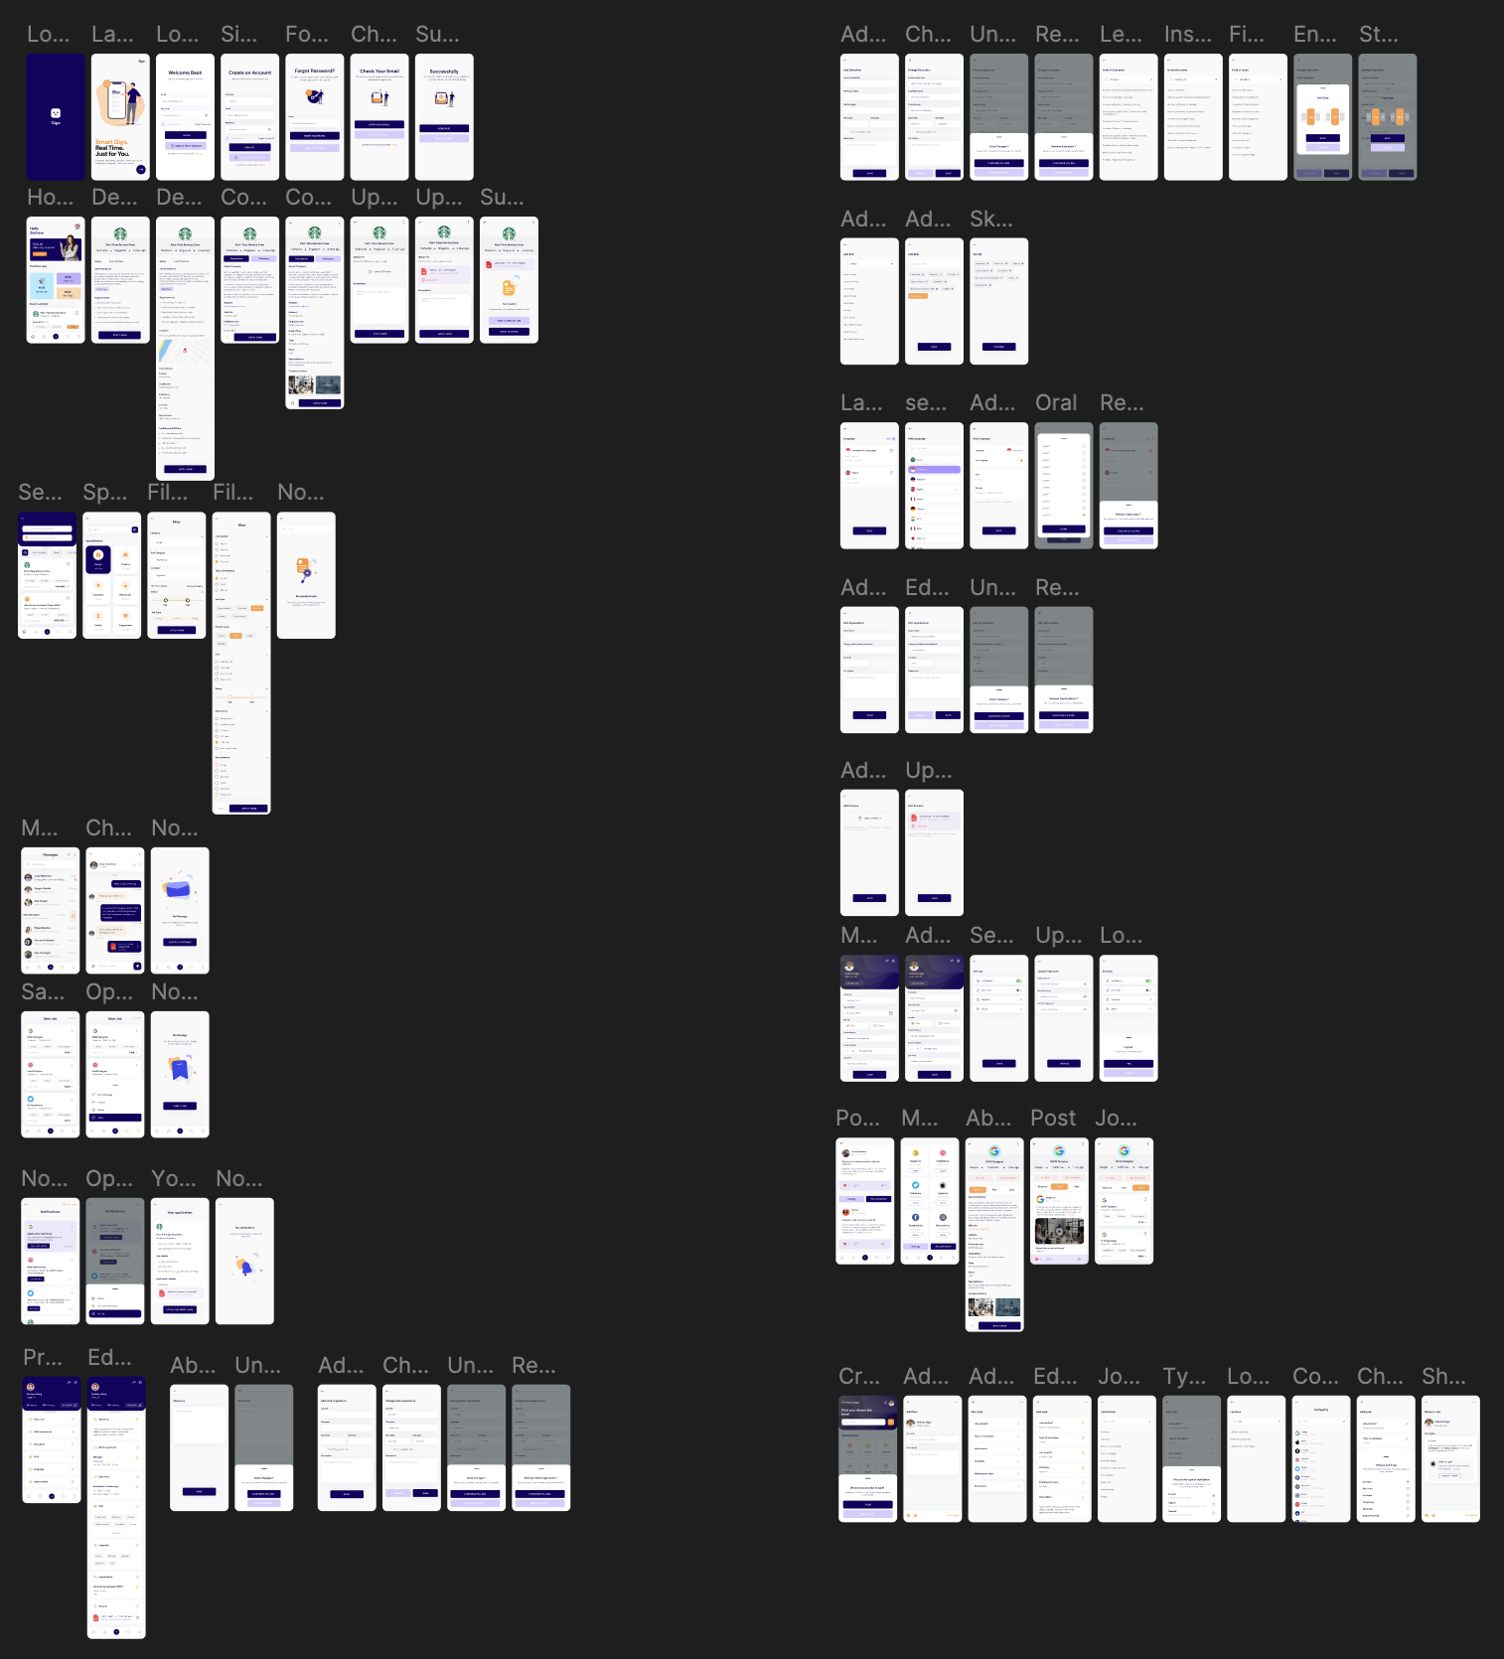

Figure B-1: Onboarding – Welcome Landing Page

文本

AI 生成的内容可能不正确。

Figure B-2: Authentication – Secure Login Interface

图形用户界面, 应用程序

AI 生成的内容可能不正确。

Figure B-3: Registration – New User Sign-Up Form

图形用户界面, 应用程序

AI 生成的内容可能不正确。

Figure B-4: Integration – Google OAuth Sign-In

图形用户界面, 应用程序

AI 生成的内容可能不正确。

Figure B-5: Security – Password Reset Request Flow

图形用户界面, 应用程序, Teams

AI 生成的内容可能不正确。

Figure B-6: System Feedback – Email Verification Confirmation

图形用户界面, 应用程序

AI 生成的内容可能不正确。

Figure B-7: User Dashboard – Main Home Screen

图形用户界面, 应用程序

AI 生成的内容可能不正确。

Figure B-8: Discovery Engine – Job Search and Filtering Results

图形用户界面, 应用程序

AI 生成的内容可能不正确。

Figure B-9: Upskilling – Course Promotion Interface

图形用户界面, 网站

AI 生成的内容可能不正确。

Figure B-10: Dynamic Query Result Feed

**图形用户界面, 应用程序, Teams

AI 生成的内容可能不正确。**

Figure B-11: Categorical Filtering Interface

**图片包含 图形用户界面

AI 生成的内容可能不正确。**

Figure B-12: Temporal & Contextual Sorting

**图形用户界面, 应用程序

AI 生成的内容可能不正确。**

Figure B-13: Job Detail View (Pre-Transaction)

**图形用户界面, 文本, 应用程序

AI 生成的内容可能不正确。**

Figure B-14: Transaction Success Feedback

**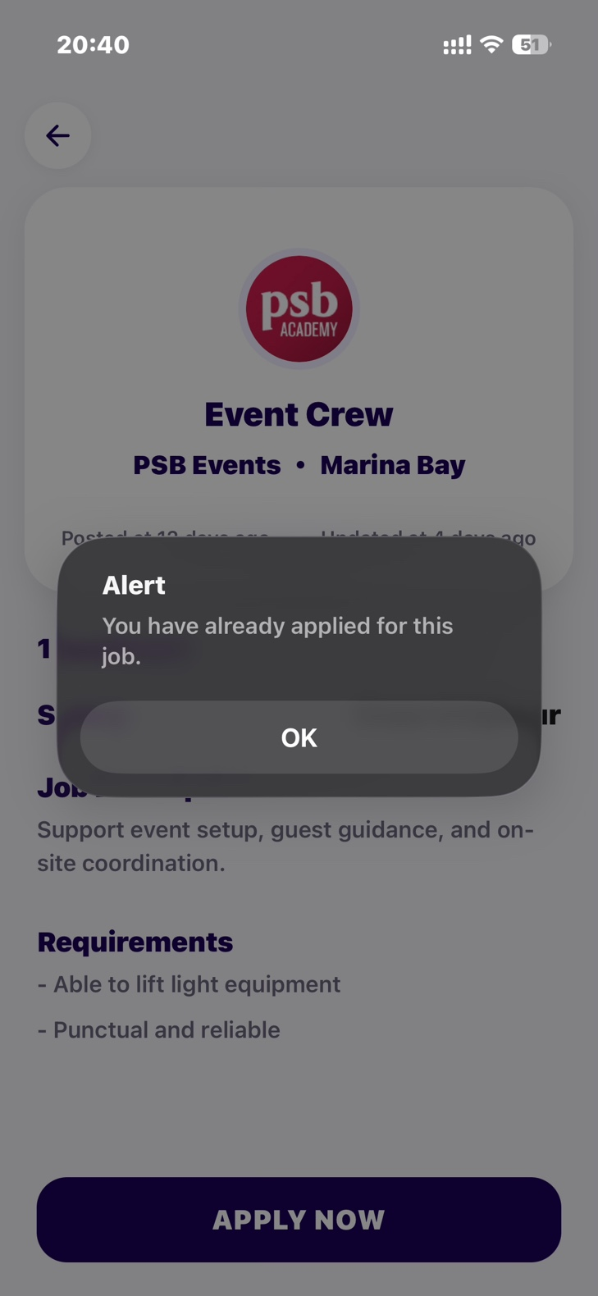**

Figure B-15: Integrity Constraint Enforcement

**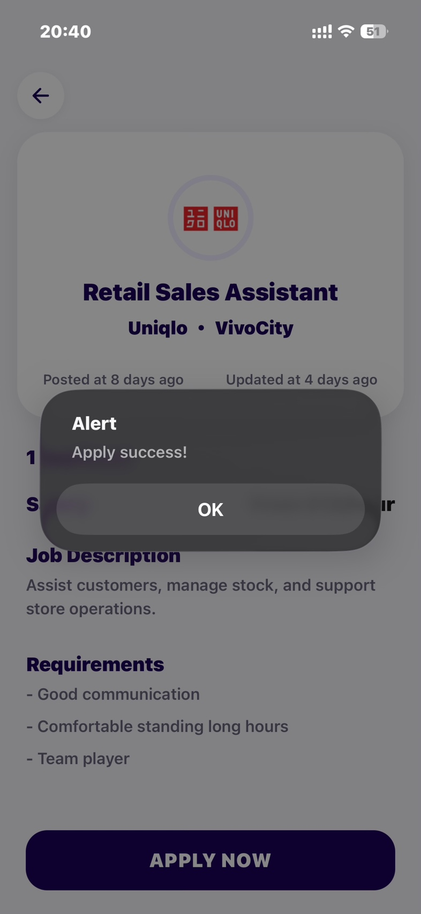**

Figure B-16: Application Repository Dashboard

**图形用户界面, 文本

AI 生成的内容可能不正确。**

Figure B-17: Job Detail View (Post-Transaction)

**图形用户界面, 文本, 应用程序

AI 生成的内容可能不正确。**

Figure B-18: Destructive Action Confirmation

**图形用户界面, 文本, 应用程序, 聊天或短信

AI 生成的内容可能不正确。**

Figure B-19: Gigo AI Assistant (Visual Prototype)

**图形用户界面, 应用程序

AI 生成的内容可能不正确。**

Figure B-20: Job Watchlist Integration

**图形用户界面, 文本, 应用程序, 聊天或短信

AI 生成的内容可能不正确。**

Figure B-21: Watchlist Management Interface

**图形用户界面, 应用程序

AI 生成的内容可能不正确。**

Figure B-22: Employer Information Transparency

**图形用户界面, 应用程序

AI 生成的内容可能不正确。**

Figure B-23: Destructive Action Confirmation (Watchlist)

**图形用户界面, 文本, 应用程序, 聊天或短信

AI 生成的内容可能不正确。**

**Appendix D: Meeting minutes**

|  |  |  |  |
| --- | --- | --- | --- |
| **Course Code:** | **COMP3851 Part A&B T2 & T3 2025** | **Trimester:** | Trimester 3 |
| **Industry Supervisor’s Name:** | LEE Han John | **Signature & Date:** | John Lee  22nd September 2025  (First Fortnight Meeting) |
| **Project Title:** | Gig Job Placement Services | **Project Group Size:** | **5 students:**  1. Zihao Wang (Project manager)  2. Jiawei Shen (Deputy project manager)  3. Yixun Tian  (Backend)  4. Yiheng Li  (Documentation)  5. Jiaxing Xiong  (Full stack) |

|  |  |  |
| --- | --- | --- |
| **Date** | **Brief Summary of Meeting** | **Number of Students Attended** |
| 22nd September 2025 11:30am  (First Fortnight Meeting) | **MEETING NOTES**   * Reviewed and discussed team roles and task allocations for the development of the gig job placement mobile app. * Presented the development timeline and technical stack to supervisor John Lee. * Supervisor John Lee emphasized the importance of team collaboration and provided feedback on incorporating more detailed development plans. * Discussed the technical stack (React Native + Supabase) and its implementation. * Planned weekly development milestones and deliverables.   **Current Issues to Discuss**   * Finalizing task allocations based on team strengths and availability. * Addressing John Lee’s feedback on enhancing collaboration and detailing development plans. * Ensuring the technical stack aligns with project requirements (e.g., real-time updates, user privacy).   **Future Issues to Discuss**   * Refining real-time job vacancy updates and AI matching algorithms. * Planning user testing for cross-platform compatibility (iOS/Android). * Validating the monetization model with AdMob integration.   **Notes**  1.Task Assignments:  Confirmed roles as per the task allocation table.   * Zihao Wang: Develop app screens for Authentication and Profile and incorporate privacy-focused UI/UX elements. * Jiawei Shen: Develop app screens for Search and Jobs, and lead market analysis and competitor research. * Yixun Tian: Handle Supabase schema, triggers, and real-time logic. * Yiheng Li: Consolidate all documentation, including reports, meeting minutes, and PPT. * Jiaxing Xiong: Contribute across the stack by developing application and advertisement interfaces, implementing backend services, and stepping in wherever additional support is needed.   2.Supervisor’s Feedback:   * Strengthen communication among team members to ensure smooth progress. * Provide more detailed weekly milestones to make workload distribution clearer. * Provide more detailed weekl milestones to make workload distribution clearer. * Emphasized maintaining detailed technical logs to track development progress.   3.Next Steps:   * Start developing app pages according to Figma designs. （Zihao Wang, Jiawei Shen） * Begin integrating UI elements into functional app screens. （Zihao Wang, Jiawei Shen） * Update the Gantt chart with current progress and responsibilities. (Yiheng Li). * Continue backend development and real-time logic integration (Yixun Tian). * Conduct ongoing documentation updates including meeting notes and progress reports (Yiheng Li). * Support full-stack development where needed (Jiaxing Xiong). | **Attendees (and time of arrival)**  present from 11:30 am through 12:40 noon:  1. Zihao Wang (Project manager)  2. Jiawei Shen  (Deputy Project manager)  3. Yixun Tian (Backend)  4. Yiheng Li  (Documentation)  **Note:**  Jiaxing Xiong (Full stack) was absent due to a fever. During the meeting, the team informed John Lee on his behalf, and he was granted leave. After recovering, he sent an email to the supervisor to confirm. |

|  |  |  |  |
| --- | --- | --- | --- |
| **Course Code:** | **COMP3851 Part A&B T2 & T3 2025** | **Trimester:** | Trimester 3 |
| **Industry Supervisor’s Name:** | LEE Han John | **Signature & Date:** | John Lee  13th October 2025  (Second Fortnight Meeting) |
| **Project Title:** | Gig Job Placement Services | **Project Group Size:** | **5 students:**  1. Zihao Wang (Project manager)  2. Jiawei Shen (Deputy project manager)  3. Yixun Tian  (Backend)  4. Yiheng Li  (Documentation)  5. Jiaxing Xiong  (Full stack) |

|  |  |  |
| --- | --- | --- |
| **Date** | **Brief Summary of Meeting** | **Number of Students Attended** |
| 13th October 2025 11:30am  (Second Fortnight Meeting) | **MEETING NOTES**   * Discussed the feasibility of converting Figma design pages to code (Figma to Code) and obtained approval from the sponsor (teacher) to proceed with this new development plan. * Explored career development topics, including CV/resume preparation advice from the teacher. * Analyzed the gig job market in Singapore and compared it with markets in the USA, China, and other Southeast Asian countries to inform project positioning.   **Current Issues to Discuss**   * Figma to Code tool selection: Finalize and configure Figma plugins supporting React Native that export clean, reusable component code (e.g., Locofy or Builder.io) for smooth transition to the SDLC implementation phase. * SDLC testing plan refinement: Develop detailed testing plans, including unit and integration tests for core functions (e.g., user authentication, job search/matching), to verify the accuracy and functionality of automated code. * Backend interface preparation: Yixun Tian to accelerate completion of Supabase backend interfaces (API endpoints) to ensure data models align with Figma UI structure for frontend integration.   **Future Issues to Discuss**   * SDLC deployment preparation: Plan app packaging, signing, and release processes for App Store/Google Play, considering CI/CD pipelines for the maintenance phase. * Code quality control: Establish a code review checklist for automated generated code to ensure readability and performance standards. * User feedback loop design: Incorporate mechanisms for user feedback collection to support iterative improvements in the SDLC maintenance phase.   **Notes**  1. **SDLC - Design and Implementation Phase Major Decisions：**  Confirmed roles as per the task allocation table.   * Figma to Code feasibility justification: The team successfully argued the feasibility of using automated tools to convert Figma designs to code, aiming to efficiently import SDLC design outputs into the implementation phase and significantly shorten UI development time. * Sponsor approval and guidance: The teacher (sponsor) formally approved this technical route but emphasized that project success depends on developers' manual review of auto-generated code and addition of business logic to ensure robustness and maintainability.   **2. Career Development and Market Insights:**   * CV/Resume consultation: The team sought advice from the teacher on CV writing. Key guidance focused on transforming project responsibilities into quantifiable achievements (e.g., "improved efficiency by X% using new technology"), with emphasis on ATS optimization and job-specific customization. * Gig job market comparison: The meeting discussed Singapore's gig market (ranked 8th globally as a top work destination in Asia, attracting talent in marketing, media, digital, data science, and AI due to high safety, salaries, and stability) versus the USA (higher salaries and opportunities but differences in lifestyle, health insurance, and culture), China/East Asia (poorer work-life balance compared to Southeast Asia), and other Southeast Asian countries (optimistic hiring outlook from economic integration, political stability, and FDI from the US/China). This provided valuable market intelligence for the "Gig Job Placement Services" project positioning.   **3. SDLC Phase Focus Tasks and Responsibility Allocation:**   * Zihao Wang & Jiawei Shen (Project Manager/Deputy Manager): Responsible for initial Figma to Code conversion of core UI screens (e.g., Profile/Search) and leading functional integration of interfaces. * Jiaxing Xiong (Full Stack/Code Quality): Focus on SDLC implementation phase code optimization and business logic injection. Primary duties include reviewing and debugging auto-generated code to meet team Clean Code standards, and manually coding complex interactions and state management. * Yixun Tian (Backend): Ensure all necessary Supabase APIs (data retrieval, storage, authentication) are ready and initially tested before frontend UI integration. * Yiheng Li (Documentation/Planning): Immediately update the project plan (Gantt Chart) to include Figma to Code research, selection, implementation, and code review as key tasks and milestones in the SDLC implementation phase.   Career preparation: All team members to update key achievement descriptions in personal CVs/resumes based on the teacher's advice before the next meeting.  3.Next Steps:   * Technical implementation: (Zihao Wang, Jiawei Shen, Jiaxing Xiong) Complete Figma to Code tool configuration and integration within this week, starting code generation and manual optimization for the first core app interface. * Backend support: (Yixun Tian) Complete API interfaces for at least two key functions and provide testing documentation. * Documentation update: (Yiheng Li) Submit updated project plan detailing weekly task breakdowns for the SDLC implementation phase. * Career preparation: All team members to update key achievement descriptions in personal CVs/resumes based on the teacher's advice before the next meeting. | **Attendees (and time of arrival)**  present from 11:30 am through 12:55 noon:  1. Zihao Wang (Project manager)  2. Jiawei Shen  (Deputy Project manager)  3. Yixun Tian (Backend)  4. Yiheng Li  (Documentation)  5. Jiaxing Xiong  (Full stack)  **Note:**  All team members attended the meeting and reached consensus on implementing the new technology route. |

|  |  |  |  |
| --- | --- | --- | --- |
| **Course Code:** | **COMP3851 Part A&B T2 & T3 2025** | **Trimester:** | **Trimester 3** |
| **Industry Supervisor’s Name:** | **LEE Han John** | **Signature & Date:** | **John Lee**  **5th November 2025**  **(Third Fortnight Meeting)** |
| **Project Title:** | **Gig Job Placement Services** | **Project Group Size:** | **5 students:**  **1. Zihao Wang (Project manager)**  **2. Jiawei Shen (Deputy project manager)**  **3. Yixun Tian**  **(Backend)**  **4. Yiheng Li**  **(Documentation)**  **5. Jiaxing Xiong**  **(Full stack)** |

|  |  |  |
| --- | --- | --- |
| **Date** | **Brief Summary of Meeting** | **Number of Students Attended** |
| 5th November 2025 10:45am  (Third Fortnight Meeting) | **MEETING NOTES**   * Supervisor reminded team to label each fortnightly record with the correct meeting date and sequence. * Supervisor highlighted that the WIL course, coordinated by Korea and Australia, aims to build students’ professional readiness. * The team updated on the current app development progress * Supervisor discussed how AI reshapes industries with need for use of AI tools in various aspects of design application. * The team will present all implemented pages and code to supervisor in the next meeting for review.   **Current Issues to Discuss**   * Ensuring each fortnightly meeting record includes the correct date and sequence label. * Maintaining documentation updates aligned with ongoing development progress. * Reviewing code quality and UI alignment between designed and implemented pages. * Reflecting on AI applications potentially relevant to the project’s job-matching logic.   **Future Issues to Discuss**   * Demonstrating all completed app pages and code to John Lee in the next meeting. * Exploring AI-based matching or automation features if time allows. * Preparing initial user testing plans for app usability. * Continuing to ensure project outcomes meet WIL course expectations.   **Notes**   1. **Development Progress:**  * The team is currently focusing on overall system planning and preliminary interface layout design. * Backend structure and database logic are still under refinement and review. * Documentation is being updated regularly to reflect meetings and project direction.  1. **Supervisor’s Feedback:**  * Maintain a consistent and clearly dated meeting record format. * Focus on presenting the main framework and logic flow rather than complete functionalities. * Continue to reflect on how AI trends might connect to the project theme.   **3. Next Steps:**   * Complete basic layout and backend framework setup. * Prepare a minimal working prototype for demonstration in the next meeting. * Complete the necessary documentation and progress to a complete system with artifacts to be showcased. | **Attendees (and time of arrival)**  present from 10:45 am through 12:05 noon:  1. Zihao Wang (Project manager)  2. Jiawei Shen  (Deputy Project manager)  3. Yixun Tian (Backend)  4. Yiheng Li  (Documentation)  5.Jiaxing Xiong  (Full Stack)  **Note:**  All team members attended the meeting and actively participated in the discussion.  Supervisor shared insights on AI’s role in shaping global industries and guided the team on improving documentation and professional reflection practices.  The team collectively acknowledged the importance of adapting AI concepts into future project enhancements. |
| **Date** | **Brief Summary of Meeting** | **Number of Students Attended** |
| 27th November 2025 11:00 am to 12:15 pm  (Final Fortnight Meeting) | **MEETING NOTES**   * Supervisor reviewed the various stages of implementation and verified the artifacts of the solution. * The team members individually provided their portion of the work done and updated on the final application/system. * Supervisor was satisifed with the user interface, the logical processes involved in the GIG solution and all the necessary test-data used and the design characteristics originally declared in the systems objectives and expected system design/solution.   **Design scope and verification against the original project objectives:**   * The design and solution witnessed by the superviers met the original project scope and plan. * The documentation provided was complete. * The code quality and User interface and working model was in accordance to the stated objectives for this project and met the parameters stated in the initial design scope and objectives. * Process and data testings were validated during this meeting and the supervisor was able to witness and validate that the required specifications for robustness and logic were evident. * The test data were adequate and provided enough range to confirm that the procedures were well tested and the system works without any defects or errors with proper error detection and correction with good user feedback.   **Completed Solution with artifacts duly presented.**   * Demonstration of all completed application pages and code during this final meeting. * AI-based matching and automation features were presented. * All user testing activities met the requirements of the solution/design objectives.  1. **Development Progress:**  * The team has done well in delivering a fully working system vis-à-vis the original design objectives. * Backend structure and database logic were review and validated. * Documentation is of a good quality and complete.  1. **Supervisor’s Feedback:**  * The designed system/solution works according to the original project scope and objectives. * This team had complete and met the project objectives and design scope. | **Attendees (and time of arrival)**  present from 10:45 am through 12:05 noon:  1. Zihao Wang (Project manager)  2. Jiawei Shen  (Deputy Project manager)  3. Yixun Tian (Backend)  4. Yiheng Li  (Documentation)  5.Jiaxing Xiong  (Full Stack)  **Note:**  All team members attended the meeting and actively participated in the discussion.  Supervisor highlighted his satisfaction at the effort and quality of the work and delivered by the team members. |

**Appendix E: Teamwork**

图形用户界面, 应用程序

AI 生成的内容可能不正确。

图形用户界面, 应用程序, Teams

AI 生成的内容可能不正确。图形用户界面, 应用程序, Teams

AI 生成的内容可能不正确。